NSDM INDUSTRY SOCIAL MEDIA MESSAGES

OVERVIEW
Below are messages that CGA members can deploy during National Safe Digging Month (NSDM) to personally spread safe digging awareness among your networks. Use the suggested posts and accompanying infographics across your personal LinkedIn, Twitter/X, Facebook and Nextdoor accounts to reinforce the 811 message to your colleagues, peers and neighbors.

To download the graphics shared below, please visit: CGA's 2022 DIRT Report Tools.

LINKEDIN POSTS

Copy:
Each year, damages to underground #utilities cost the U.S. an estimated $30 billion and recent data reveals some troubling increases. This National Safe Digging Month, raise awareness of #811beforeyoudig to help us meet the @Common Ground Alliance #50in5 challenge to reduce damages by 50% in five years.

#NationalSafeDiggingMonth marks the start of the busy digging season, reminding #DamagePrevention professionals that we have a shared responsibility to reduce damages to vital #infrastructure by committing to safe digging practices and raising awareness of #811 services. Learn how you can help lower the cost at www.811beforeyoudig.com #811BeforeYouDig #50in5

Suggested graphics:
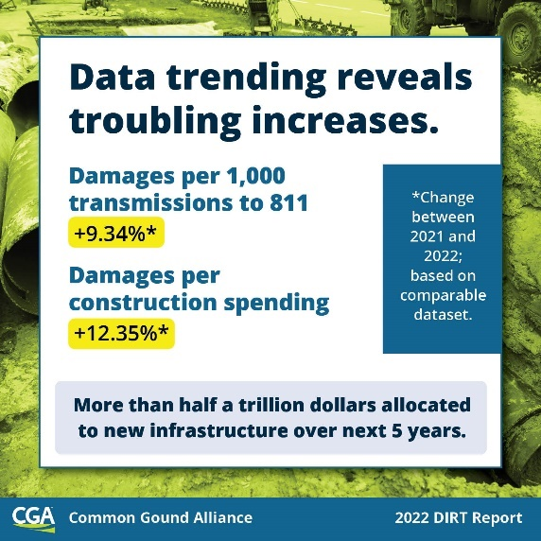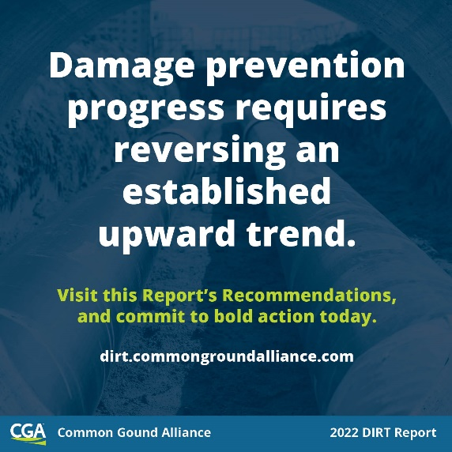

Copy:
#DamagePrevention pros, do your part in raising awareness about #811beforeyoudig this National Safe Digging Month!

According to CGA’s 2022 DIRT Report, #telecom and #utility work contributed to the most damages. Make sure that you include municipal #broadband, water and sewer stakeholders in your outreach to help drive these damages down in your area. For more information and additional NSDM resources, visit www.commongroundalliance.com. #NSDM #811BeforeYouDig #KnowWhatsBelow

Suggested graphics:
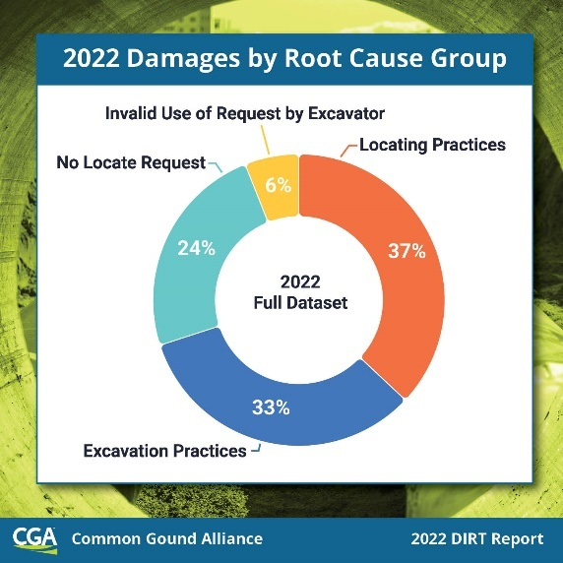

FACEBOOK POSTS

Copy:
Backhoes contribute to more underground utility damage than any other equipment, and we thank excavators for their increased reporting. Remember to #Contact811 before you get in the cab. One simple ticket request can make all the difference – protect yourself and your livelihood by contacting 811 before you dig.

Learn more at www.811beforeyoudig.com #Contact811 #811BeforeYouDig #NSDM

Suggested graphics:
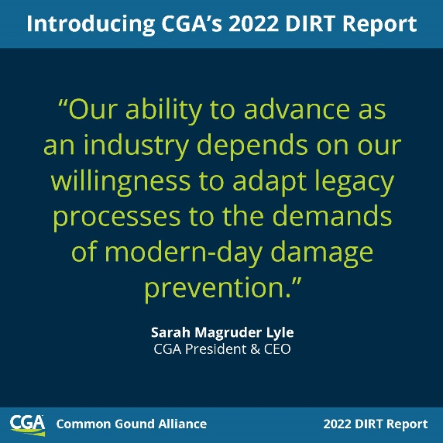

Copy:
According to CGA’s 2022 DIRT Report, 76% of all damages can be tied back to just six root causes. It is our shared responsibility as #damageprevention stakeholders to work together to decrease these persistent causes of damages.

Learn more about how your organization can contribute to our push to reduce damages by 50% in five years this National Safe Digging Month at www.commongroundalliance.com. #NSDM #Contact811 #50in5

Suggested infographic:

TWITTER/X POSTS

Backhoes contribute to more underground utility damage than any other equipment, and for the first time, excavators were the top reporting source. #Contact811 and one simple ticket request can protect you and your livelihood. Learn more at www.811beforeyoudig.com #Contact811 #811BeforeYouDig #NSDM

Suggested graphic:
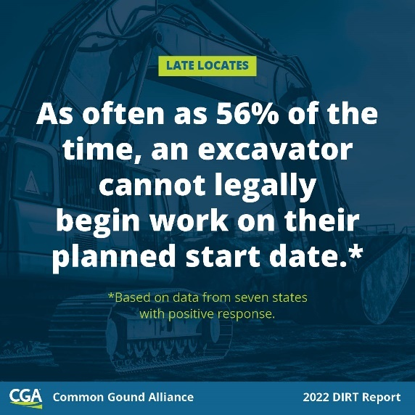

According to @CGAConnect’s 2022 DIRT Report, 76% of all damages can be tied to just six root causes. Learn more about how you can contribute to our push to reduce damages by 50% in five years this National Safe Digging Month at www.commongroundalliance.com #NSDM #Contact811 #50in5

Suggested infographic:

NEXTDOOR POST

Copy:
Neighbors, did you know that April is National Safe Digging Month (NSDM)? As the weather gets warmer and we all start spending more time outside, it’s likely that many of us will tackle some DIY projects that involve digging. Even for small home projects like planting trees or installing a fence, remember to always contact 811 before you dig, every time!

When you contact 811, your local utility companies mark the approximate location of any buried lines in your yard so that you don’t risk injuring yourself or disrupting utility service to the neighborhood. It’s easy to make your free request by calling 811 or going online to [INSERT 811 CENTER URL OR 811beforeyoudig.com]. Every digging project, no matter how large or small, requires contacting 811. Visit www.811beforeyoudig.com for more info. Happy – and SAFE – digging!

Suggested graphic (from NSDM 2024 toolkit):

