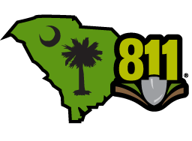
Celebrate National Safe Digging Month with a FREE SC811 Banner!

How Do I Participate?
Review the available banners, fill out the order form, and then coordinate pickup!

Banner Options:
2’x4’
(1A) 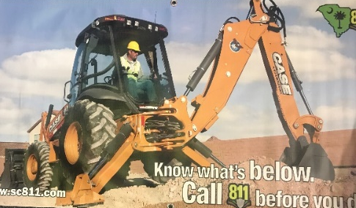(2B) 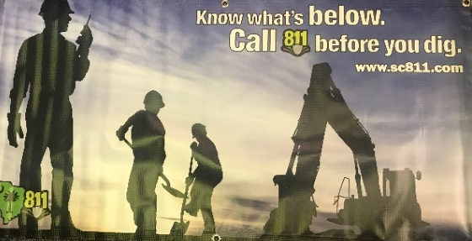

(3A) 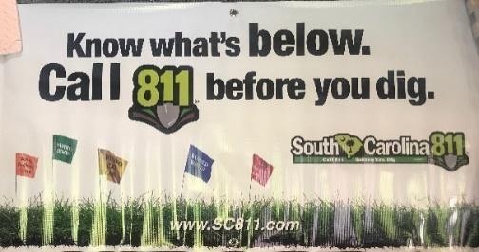(5E) 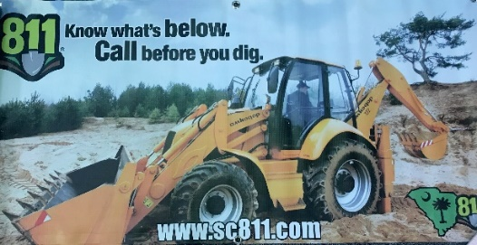

(7G) 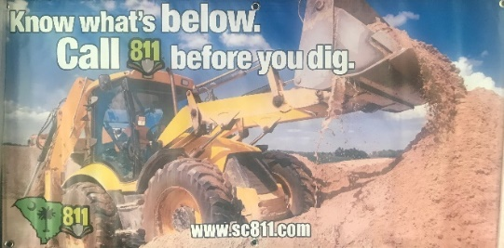(9H) 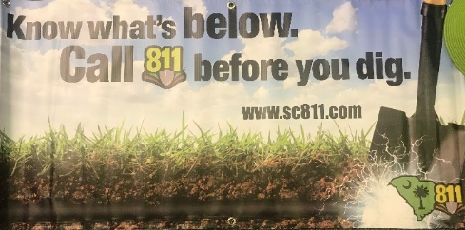

(10A-Wind Slit Mesh-2019 Banner) 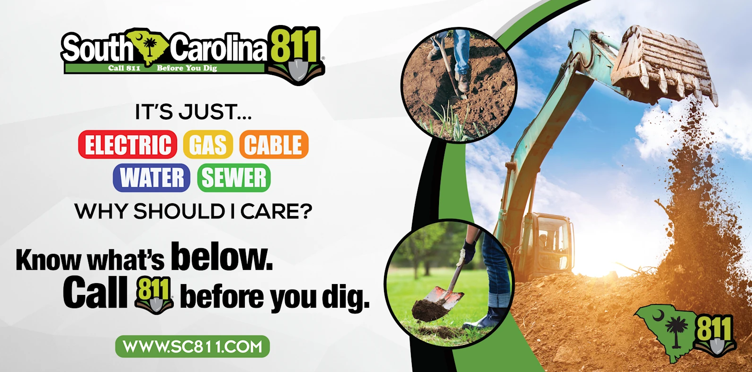
4’x8’

(10A)

Banners must be picked up at a local Utility Coordinating Committee Meeting or a coordinated pickup location.

South Carolina 811 Banner Order Form

Contact Name:_________________
Phone:_____________ Email:_____________________ Address:______________________
City, State, Zip Code: ____________________________

Banner Choice and Quantities:

2’x4’:
(1A)___ (2B)___ (3A)___(4A)___(5E)___(7G)___(9H)___ (10A)___

4’x8’:
10A)___

I agree to:
- Take photos of banner(s) and submit
- Provide location of banner(s) in order to get my banner free of charge: _____ (initials)

Signature:______________________ Date:_____________________

Email Order Form:

Lori.Slice@sc811.com
810 Dutch Square Blvd
Suite 320
Columbia, SC 29210
(803)451-7718

